Yea Community House

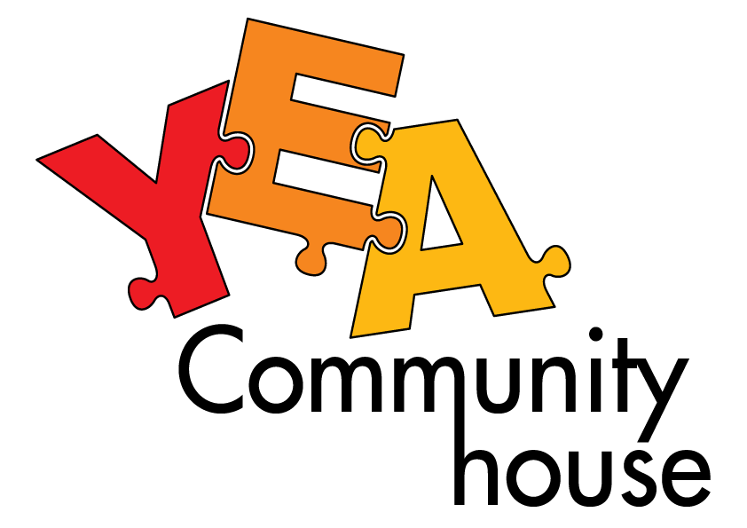

Ph: 5797 3070 Email: info@yeahouse.org.au

PO Box 78 Yea Vic 3717

**Enrolment Form**

Name: ................................................................

Address:........................................................................................................................................................................................................................................................................................................................................

Phone...................................................................................

Mobile....................................................................................

Email:....................................................................................

**Course Details:**

Name:…………………………………………………..

Cost:……………………………………………………

Day/Time:................................................................

I understand that information used on this form will be used to record my enrolment details and may be used for the purpose of planning future educational & recreational programs. It may also be included in statistical reports to government funding bodies such as Department of Human Services.

YEA Community House

BSB: 633000

ACC: 151322187

**Signature: Date:**